**LAB # 13**

**Object:**

Understanding the Bridge Pattern.

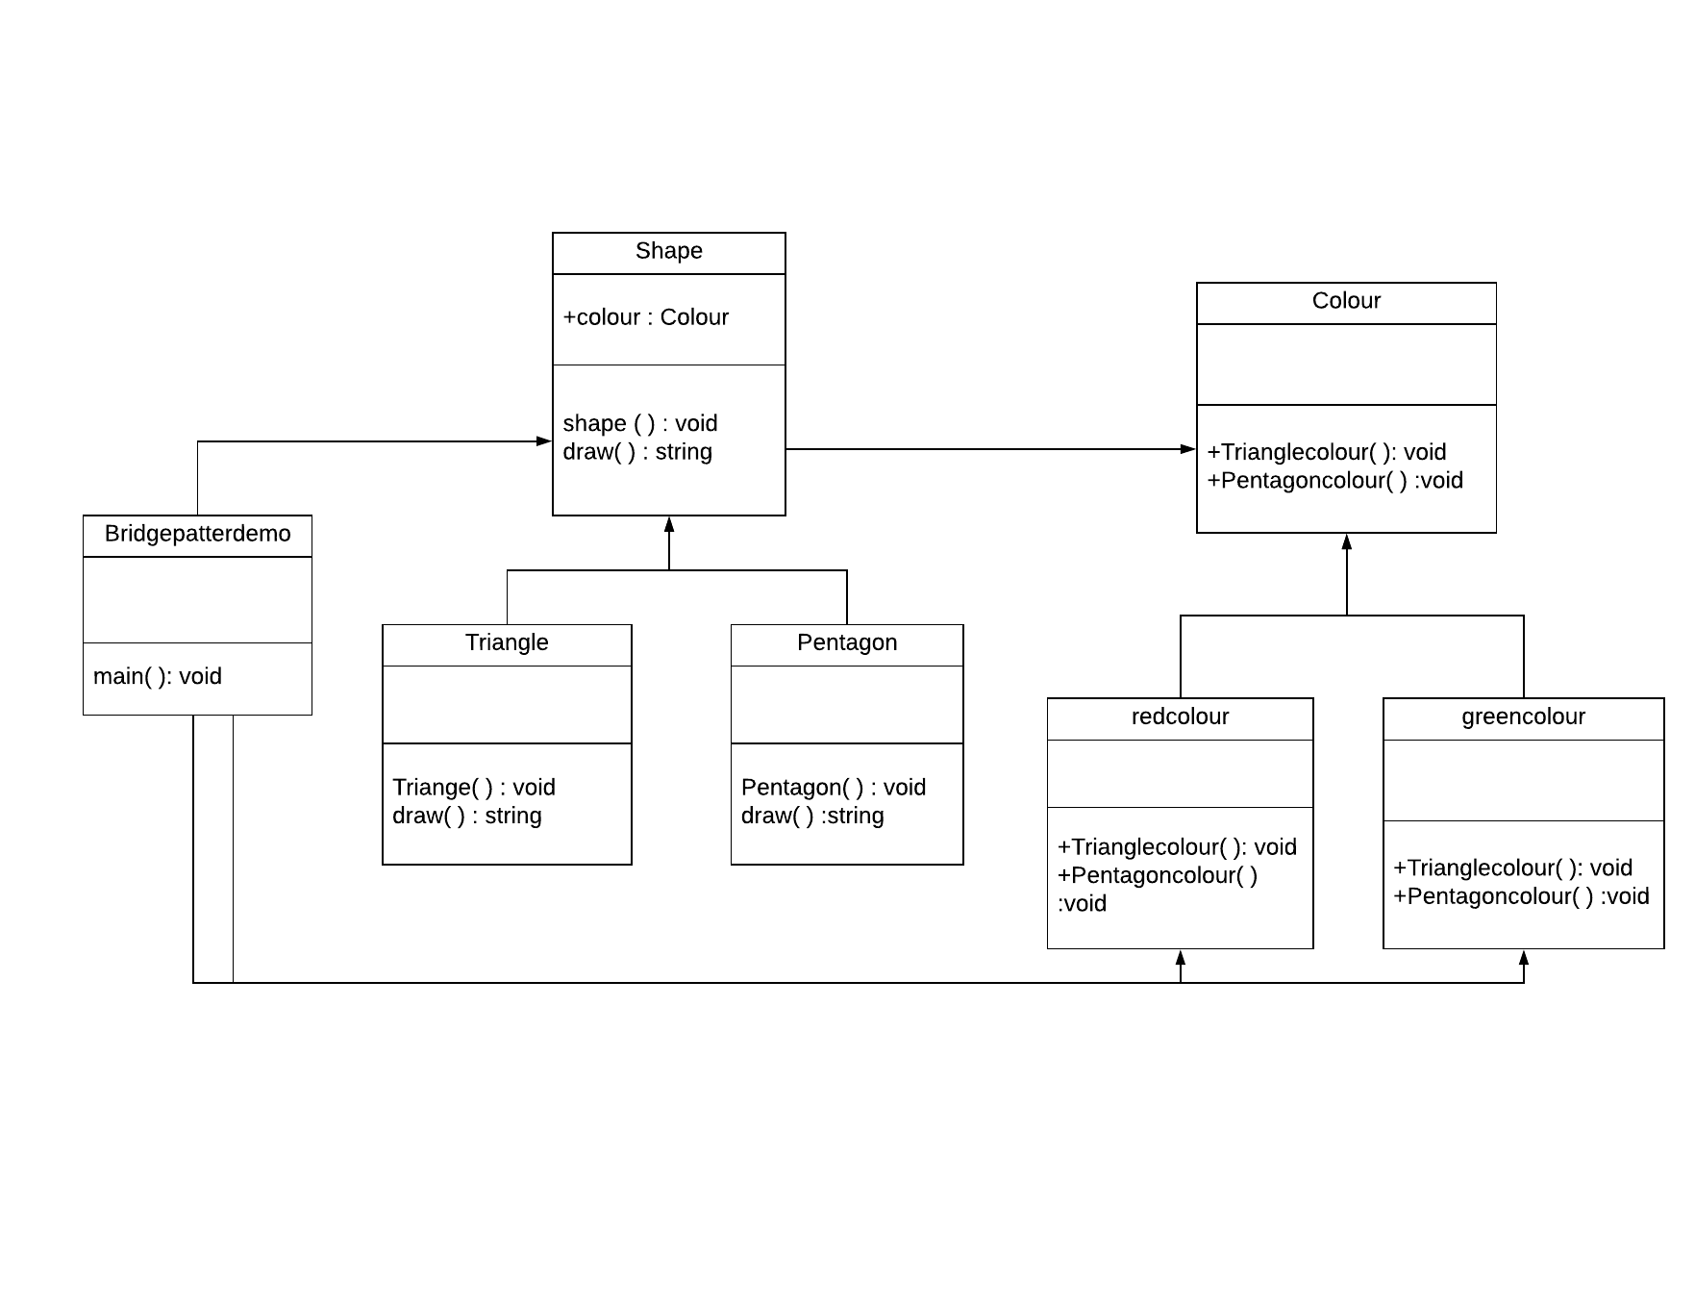

**JUSTIFICATION:**

* Bridge implementer interface between shape and colour
* Abstract class *Shape* using the colour interface.
* Concrete class implementing the *Shape* interface.
* Shape and *colour* classes to colour different triangles and pentagons.